## A PROJECT REPORT ON

**“HAND SIGN DETECTION FOR DEAF AND DUMB PEOPLE”**

SUBMITTED TO THE SAVITRIBAI PHULE PUNE UNIVERSITY, PUNE IN THE SUCCESSFUL FULFILLMENT OF THE REQUIREMENTS

FOR THE AWARD OF THE DEGREE OF

**BACHELOR OF ENGINEERING (COMPUTER ENGINEERING)**

**SUBMITTED BY**

## RIDDHI MUKKAWAR EXAM NO.: B190244375

**SRUSHTI BHASME EXAM NO.: B190244227**

## SHREYA THAKUR EXAM NO.: B190244503



**DEPARTMENT OF COMPUTER ENGINEERING DR. D. Y. PATIL INSTITUTE OF TECHNOLOGY**

PIMPRI, PUNE 411018

## SAVITRIBAI PHULE PUNE UNIVERSITY 2022 - 2023



**CERTIFICATE**

This is to certify that the project report entitled

**HAND SIGN DETECTION FOR DEAF AND DUMB PEOPLE**

Submitted by

## RIDDHI MUKKAWAR EXAM NO.: B190244375

**SRUSHTI BHASME EXAM NO.: B190244227**

## SHREYA THAKUR EXAM NO.: B190244503

They are bonafide student of this institute and the work has been carried out by them under the supervision of **Mr. Dinesh S. Bhadane** and it is approved for the partial fulfillment of the requirement of Savitribai Phule Pune University, for the award of the degree of **Bachelor of Engineering** (Computer Engineering).

|  |  |  |
| --- | --- | --- |
| **Mr. Dinesh S. Bhadane** | **Mrs. Sunita Patil** | **Dr. Vinod Kimbahune** |
| Internal Guide | Project Coordinator | Head of Department |

**Dr. Lalit Kumar Wadhwa**

Principal,

**Dr. D. Y. PATIL INSTITUTE OF TECHNOLOGY, PIMPRI, PUNE-18**

## External Examiner Sign:

Place: Pune Date:

**ACKNOWLEDGEMENT**

It gives us great pleasure in presenting the project report on **‘Hand Sign Detection System for Deaf and Dumb People’**.

We would like to take this opportunity to thank our internal guide **Mr. Dinesh S. Bhadane** for giving us all the help and guidance we needed. We are really grateful to them for their kind support. Their valuable suggestions were very helpful.

We are also grateful to **Dr. Vinod Kimbahune**, Head of Computer Engineering Department, Dr. D. Y. Patil Institute of Technology, Pune for his indispensable support and suggestions.

Riddhi Mukkawar Srushti Bhasme Shreya Thakur

(B.E. Computer Engineering)

**ABSTRACT**

Communication is an essential component of existence. Around 360 million people worldwide suffer from hearing loss, 32 million of them are children, and their lives are not as simple as they may be for human beings without boundaries. People who are hard of hearing or almost deaf find it difficult to use cell phones since they can't get data anywhere due to a lack of administrators. Because of their hearing impairment, which is an invisible disability, they have difficulty reading and writing, as well as perusing and seeing all data on cell phones. The increase in engagement achieved by hard of hearing children over four years is equivalent to the addition of one year for hearing children. This group of people with disabilities does not have access to any visible text-based info. To provide benefits to those who are deaf and dumb or hard of hearing in order to promote their social integration and communication. This project provides a Python-based Sign Language Recognition system capable of identifying images and converting it to the corresponding text.

**Key words:** Hand Sign Detection, object detection using Neural Network, Deep Learning, image processing, Artificial intelligence, Classification etc.

**INDEX**

1. Introduction 1
   1. Overview 1
      1. Motivation 2
      2. Problem Definition 2
      3. Objectives 3
2. Literature Survey 4
   1. Study Of Research Paper 5
3. Software Requirement Specification 10
   1. INTRODUCTION 11
      1. Project Scope 11
      2. Assumption and Dependencies 11
   2. FUNCTIONAL REQUIREMENT 11
   3. EXTERNAL INTERFACE REQUIREMENT 11
      1. User Interface 11
      2. Hardware Interfaces: 11
      3. Software Interfaces 12
   4. NON FUNCTIONAL REQUIREMENT 12
      1. Performance Requirements 12
      2. Safety Requirement 13
      3. Software Quality Attributes 13
   5. SYSTEM REQUIREMENTS 14
      1. Database Requirements 14
      2. Software Requirements 14
      3. Hardware Requirements 15
   6. Analysis Models: SDLC Model to be applied 16
      1. Project Resource 17
      2. SDLC Model 17
      3. System Implementation Plan 18
4. System Design 19
   1. System Architecture 20
   2. Data Flow Diagram 22
   3. UML DIAGRAMS 24
5. Project Implementation 29
   1. Overview of Project Modules 30
   2. Tools and Technologies Used 30
   3. Algorithms 30
6. Software Testing 31
   1. Type Of Testing 32
   2. Test Cases and Test Results 32
7. Results 33
   1. Outcomes 34
   2. Screenshots 35
8. Conclusion 36
   1. Conclusion 37
   2. Future Work 37

Annexure A Appendix A 38

Annexure B Appendix B 42

Annexure C Plagiarism Report 48

References 50

**List of Figures**

3.1 SDLC Model 18

* 1. System Architecture 21
  2. Data Flow diagram 23
  3. Data Flow diagram 23
  4. Data Flow diagram 24
  5. Use Case Diagram 26
  6. Activity Diagram 27
  7. Sequence Diagram 28
  8. Class Diagram 29
  9. Entity Relationship Diagrams 29

7.1 Results and Screenshots 35

# CHAPTER 1 INTRODUCTION

## OVERVIEW

People who are deaf and dumb often tend to feel uncomfortable around other people, when drawing attention to their hearing problem. Those people want to be like their friends with good hearing, so this drives a thought in them to mainly keep to themselves and to not take part in activities with those normal people. Sign languages are used by mute people as a medium of communication. Sign languages are used to convey thoughts with symbols and objects etc. They also convey a combination of words and symbols(i.e. gestures). Gestures are different patterns made by the curls and bends of the fingers. Gestures are the best medium for their communication .

Gesture-based communication is a language that predominantly uses manual correspondence to convey meaning rather than acoustically transmitted sound samples. This can include simultaneously integrating hand states, hand direction and development, arms or body development, and outer appearance to express a speaker's concerns. Gesture-based communication translators are commonly used to facilitate correspondence between hearing impaired and hearing persons. Such activities require great effort from the translator, as gesture messages are unambiguous common languages with their own syntax, distinct from those expressed in language. Non-verbal communication is an important way for individuals to communicate with one another. Ordinary people can communicate their ideas and thoughts to others through dialogue. The use of gestures as a means of communication is the sole approach for specific strategy for the meeting impaired group. The consultation-impaired community has developed their own style of life and techniques for communicating among themselves and with the general public by employing sign gestures. Rather than transmitting their ideas and concerns audibly, they transmit them using ways for sign examples. Sign signals are a nonverbal visual language that is not the same as spoken language but serves a comparable purpose. It is sometimes difficult for the meeting weaker neighborhoods to communicate their ideas and innovation to the general public. This framework was inspired by an exceptional meeting of people who have problems communicating verbally. It is intended to be used without difficulty by those who are deaf or hard of hearing. The goal of this project is to create a system prototype that automatically recognizes the speaker's sign language and translates them into text.

## Motivation

Nowadays we all use tools like voice assistants and voice searches in our day to day life for interacting with computers and other devices. But the mute people face difficulties even while interacting with humans and they cannot use these tools. Sign languages are used by mute people as a medium of communication. This lead us to work on the “Hand sign detection system for deaf and dumb people” project.

## Problem Definition

Computers are used by many people either at their work or in their spare-time. Special input and output devices have been designed over the years with the purpose of easing the communication between computers and humans, the two most known are the keyboard and mouse. Every new device can be seen as an attempt to make the computer more intelligent and making humans able to perform more complicated communication with the computer. This has been possible due to the result oriented efforts made by computer professionals for creating successful human computer interfaces. Deaf and dumb people face many problems while interacting with the people around them. They face the same problems while interacting with the computers. The main objective of our project is to solve this problem in a cost effective and user friendly way.

## Objectives

* + - * The main objective of this work is to develop an intelligent system that can easily communicate with a deaf and dumb people .
      * The underlying objective of this paper is to design an accurate algorithm that would detect the correct sign language .
      * The algorithm designed, requires less computational time, storage and reduces the cost incurred in employing additional hardware. It categorizes the alphabets (A to Z) and the digits (0 to 9) .

# CHAPTER 2

**LITERATURE SURVEY**

5

## 2.1 STUDY OF RESEARCH PAPER

1. **Paper Name:** Hypertuned Deep Convolutional Neural Network for Sign Language Recognition.

**Author:** Abdul Manna, Ahemd Abbasi ,Anam Ahsan ,Qin Xin,Abdul Javed.

**Abstract :** Sign language plays a pivotal role in the lives of impaired people having speaking and hearing disabilities. They can convey messages using hand gesture movements. American Sign Language (ASL) recognition is challenging due to the increasing intraclass similarity and high complexity. This paper used a deep convolutional neural network for ASL alphabet recognition to overcome ASL recognition challenges. This paper presents an ASL recognition approach using a deep convolutional neural network. e performance of the DeepCNN model improves with the amount of given data; for this purpose, we applied the data augmentation technique to expand the size of training data from existing data artificially. According to the experiments, the proposed DeepCNN model provides consistent results for the ASL dataset. Experiments prove that the DeepCNN gives a better accuracy gain of 19.84%, 8.37%, 16.31%, 17.17%, 5.86%, and 3.26% as compared to various state-of-the-art approaches

**Paper Name:** Detection of hand gestures with human computer recognition by using a support vector machine.

**Author:** Sura Abdulmunem Mohammed, Hissah Almutairi, Rasha Almajed.

**Abstract :** Many applications, such as interactive data analysis and sign detection, can benefit from hand gesture recognition. We offer a low-cost approach based on human-computer interaction for predicting hand movements in real time. Our technique involves using a color glove to train a random forest classifier and then predicting a naked hand at the pixel level. Our algorithm anticipates all pixels at a rate of around 3 frames per second and is unaffected by differences in the surroundings. It's also been proven that HCI-based data augmentation is more effective than any other way for enhancing interactive data. In addition, the augmentation experiment was carried out on multiple subsets of the original hand skeleton sequence dataset, each with a different number of classes, as well as on the entire dataset. On practically all subsets, the proposed base architecture improved classification accuracy. When the entire dataset was used, there was even a modest improvement. Correct identification could be regarded as a quality indicator. The best accuracy score was 94.02 percent for the HCI-model with support vector machine (SVM) classifier.

**Paper Name:** Indian Sign Language Recognition Using Eigen Value Weighted Euclidean Distance Based Classification Technique

**Author:** Joyeeta Singha , Karen Das.

**Abstract:** Sign Language Recognition is one of the most growing fields of research today. Many new techniques have been developed recently in these fields. Here in this paper, we have proposed a system using Eigen value weighted Euclidean distance as a classification technique for recognition of various Sign Languages of India. The system comprises four parts: Skin Filtering, Hand Cropping, Feature Extraction and Classification. 24 signs were considered in this paper, each having 10 samples, thus a total of 240 images was considered for which recognition rate obtained was 97%.

**Paper Name:** A comparison of machine learning algorithms applied to hand gesture recognition

**Author:** Paulo Triguerious, Fermando Riberio, Lusi Paulo Reis.

**Abstract:** Hand gesture recognition for human computer interaction is an area of active research in computer vision and machine learning. The primary goal of gesture recognition research is to create a system, which can identify specific human gestures and use them to convey information or for device control. This paper presents a comparative study of four classification algorithms for static hand gesture classification using two different hand features data sets. The approach used consists in identifying hand pixels in each frame, extract features and use those features to recognize a specific hand pose. The results obtained proved that the ANN had a very good performance and that the feature selection and data preparation is an important phase in the all process, when using low resolution images like the ones obtained with the camera in the current work

**Paper Name:** Sign Language To Speech Translation Using Machine Learning

**Author:** Aerpula Swetha, Vamja Pooja, Vundi Vedavyas.

**Abstract:** Sign language is an incredible advancement that has grown over the years. Unfortunately, there are some drawbacks that have come along with this language. Not everyone knows how to interpret sign language when having a conversation with a deaf and mute person. One finds it hard to communicate without an interpreter. To solve this, there is a need for a product that is versatile and robust. There is a need to convert sign language so that it is understood by common people. So here the aim is to get the deaf and mute people more involved to communicate and the idea of a camera-based sign language recognition system that would be in use for converting sign language gestures to text and then to speech. There are major techniques available to detect hand motion or gesture and then converting the detected information into voice such as CNN algorithm.

# CHAPTER 3

**SOFTWARE REQUIREMENT SPECIFICATION**

11

## INTRODUCTION

## Project Scope

Hand Sign Detection Systems are an important research field related to Human Computer Interaction (HCI). These systems help the specially abled users to interact with the computer and also other humans easily. This module can also be integrated with many other applications.

## Assumption and dependencies

Domain: Machine Learning Input : live camera, Webcam

## FUNCTIONAL REQUIREMENT

The system consists of 4 modules:

1. Feature point extraction: Feature points of each image get detected.
2. Feature correspondence matching: Matching of selected feature points across various image frames.
3. Point estimation: Position estimation and vision system orientation during navigation.
4. Position refinement: Location estimate based, accurate location derivation.

## EXTERNAL INTERFACE REQUIREMENT

## User Interface

* Application Based On Hand Sign Detection using Machine Learning.

## Hardware Interfaces:

* Hardware : Intel core
* Speed : 2.80 GHz
* RAM : 8GB
* HardDisk : 500 GB
* Key Board: Standard Windows Keyboard

## Software Interfaces

* Operating System: Windows 10(64 Bit)
* IDE: Spyder, PyCharm
* Programming Language : python version 3.7,3.8

## NON FUNCTIONAL REQUIREMENT

## Performance Requirements

* The performance of the functions and every module must be good. The overall performance of the software will enable the users to work recently. Performance of encryption of data should be fast. Performance of the providing virtual environment should be a fast Safety Requirement.
* The application is designed in modules where errors can be detected and exceeded easily. This makes it easier to install and update new functionality if required.

## Safety Requirement

* The application is designed in modules where errors can be detected and fixed easily. This makes it easier to install and update new functionality if required.

## Software Quality Attributes

* Our software has many quality attribute that are given below:-
* Adaptability: This software is adaptable by all users.
* Availability: This software is freely available to all users. The availability of the software is easy for everyone.
* Maintainability: After the deployment of the project if any error occurs then it can be easily maintained by the software developer.
* Reliability: The performance of the software is better which will increase the reliability of the Software.
* User Friendliness: Since, the software is a GUI application; the output generated is much user friendly in its behavior.
* Integrity: Integrity refers to the extent to which access to software or data by unauthorized persons can be controlled.
* Security: Users are authenticated using many security phases so reliable security is provided.
* Testability: The software will be tested considering all the aspects.

## SYSTEM REQUIREMENTS

## Database Requirements

Browser for SQLite (DB4S) is a high quality, visual, open source tool to create, design, and edit database files compatible with SQLite.

DB4S is for users and developers who want to create, search, and edit databases. DB4S uses a familiar spreadsheet-like interface, and complicated SQL commands do not have to be learned.

Controls and wizards are available for users to:

Create and compact database files Create, define, modify and delete tables Create, define, and delete indexes Browse, edit, add, and delete records Search records

Import and export records as text

Import and export tables from/to CSV files

Import and export databases from/to SQL dump files Issue SQL queries and inspect the results

## Software Requirements

* Anaconda Navigator: Anaconda Navigator is a desktop graphical user- interface (GUI) included in Anaconda® distribution that allows you to launch applications and easily manage conda packages, environments, and channels without using command line commands. Navigator can search for packages on.

Anaconda.org or in a local Anaconda Repository. It is available for Windows, macOS, and Linux. In order to run, many scientific packages depend on specific versions of other packages. Data scientists often use multiple versions of many packages and use multiple environments to separate these different versions.

The command-line program conda is both a package manager and an envi- ronment manager. This helps data scientists ensure that each version of each package has all the dependencies it requires and works correctly.

Navigator is an easy, point-and-click way to work with packages and environments without needing to type conda commands in a terminal window. You can use it to find the packages you want, install them in an environment, run the packages,and update them – all inside Navigator.

## Hardware Requirements RAM : 8 GB

As we are using Machine Learning Algorithm and Various High Level Libraries

## Laptop:

RAM minimum required is 8 GB. Hard Disk : 40 GB

Data Set of CT Scan images is to be used hence minimum 40 GB Hard Disk memory is required.

Processor : Intel i5 Processor IDE : Anaconda, VS Code

Anaconda is a free and open source scientific environment written in Python, for Python, and designed by and for scientists, engineers and data analysts. It features a unique combination of the advanced editing, analysis, debugging, and profiling functionality of a comprehensive development tool with the data exploration, interactive execution, deep inspection, and beautiful visualization capabilities of a scientific package.

## ANALYSIS MODELS: SDLC MODEL TO BE APPLIED

SDLC Models stands for Software Development Life Cycle Models. In this article,we explore the most widely used SDLC methodologies such as Agile . Each software development life cycle model starts with the analysis, in which the Also, here are defined the technologies used in the project, team load. One of the basic notions of the software development process is SDLC mod- els which stands for Software Development Life Cycle models. SDLC

– is a continuous process, which starts from the moment, when it’s made a decision to launch the project, and it ends at the moment of its full removal from the exploitation. There is no single SDLC model. They are divided into main groups, each with its features and weaknesses.

1. **Requirement gathering and analysis:** In this step of waterfall we identify what various requirements are needed for our project such as software and hardware required, database, and interfaces.
2. **System Design:** In this system design phase we design the system which is easily understood for the end user i.e. user friendly. We design some UML diagrams and data flow diagrams to understand the system flow and system module and sequence of execution.
3. **Implementation:** In the implementation phase of our project we have implemented various modules required to successfully get expected outcome at the different module levels. With inputs from system design, the system is first developed in small programs called units, which are integrated in the next phase. Each unit is developed and tested for its functionality which is referred to as Unit Testing.
4. **Testing:** The different test cases are performed to test whether the project modules are giving expected outcome in assumed time. All the units developed in the implementation phase are integrated into a system after testing of each

unit. Post integration the entire system is tested for any faults and failures.

1. **Deployment of System:** Once the functional and non-functional testing is done, the product is deployed in the customer environment or released into the market.
2. **Maintenance:** There are some issues which come up in the client environ- ment. To fix those issues patches are released. Also to enhance the product some better versions are released. Maintenance is done to deliver these changes in the customer environment.

All these phases are cascaded to each other in which progress is seen as flowing steadily downwards like a waterfall through the phases. The next phase is started only after the defined set of goals are achieved for the previous phase and it is signed off, so the name ”Waterfall Model”. In this model phases do not overlap.

## Project Resource

Well configured Laptop, VS Code IDE, 2 GHZ CPU speed, 2 GB RAM, Web Cam, Internet connection

## SDLC MODEL

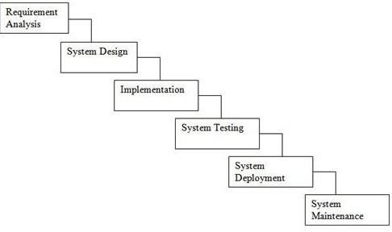

Figure 3.1

## SYSTEM IMPLEMENTATION PLAN

The System Implementation plan table, shows the overall schedule of tasks compilation and time duration required for each task.

|  |  |  |  |
| --- | --- | --- | --- |
| **Sr. No.** | **Name/Title** | **Start Date** | **End Date** |
| 1 | Preliminary Survey | 08/08/2022 | 16/08/2022 |
| 2 | Introduction and Problem Statement | 16/08/2022 | 22/08/2022 |
| 3 | Literature Survey | 16/08/2022 | 01/09/2022 |
| 4 | Project Statement | 02/09/2022 | 05/09/2022 |
| 5 | Software Requirement And Specification | 12/09/2022 | 19/09/2022 |
| 6 | System Design | 10/10/2022 | 17/10/2022 |
| 7 | Partial Report Submission | 02/11/2022 | 16/11/2022 |
| 8 | Architecture Design | 22/11/2022 | 05/12/2022 |
| 9 | Implementation | 05/12/2022 | 28/12/2022 |
| 10 | Deployment | 03/01/2023 | 17/02/2023 |
| 11 | Testing | 17/01/2023 | 24/03/2023 |
| 12 | Paper Publish | 24/04/2023 | 02/05/2023 |
| 13 | Report Submission | 21/05/2023 | 25/05/2023 |

# CHAPTER 4 SYSTEM DESIGN

20

## SYSTEM ARCHITECTURE

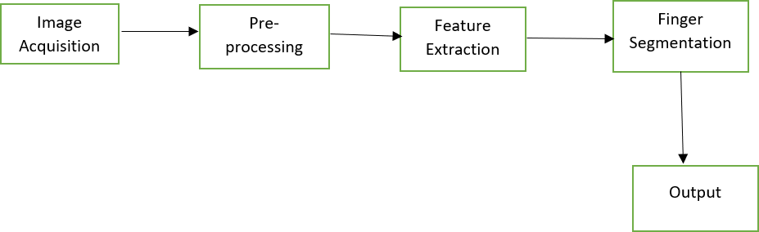

Figure 4.1: System Architecture

## Explanation

Steps involved to design the system To design the system, training dataset and test images are considered for which the following procedures are applied to get the desired results. The training set is the raw data which has a large amount of data stored in it and the test set is the input given for recognition purposes.

The whole system is designed in 5 steps:

1. **Image Acquisition** In any of the image processing techniques, the first task is to acquire the image from the source. These images can be acquired either through camera or through standard datasets that are available online. The images should be in .jpg format. The images considered here are user dependent i.e. dynamic images. The number of sample training images considered here .
2. **Pre-processing** Pre-processing is mainly done to eliminate the unwanted information from the image acquired and fix some values for it, so that the value remains the same throughout. In the pre- processing phase, the images are converted from RGB to Gray-scale and are resized to 256*256 pixels. The images considered are in .jpg format, any other formats will not be considered for further processing. During pre- processing, hands are considered to be the region of interest. It is

detected by the cascade object detector which utilizes Jones-Viola algorithm.

1. **Feature Extraction** After pre-processing, the next step is feature extraction. The extracted facial features are stored as the useful information in the form of vectors during training phase and testing phase. The following features can be considered “palm,index finger, middle finger, pinkie, thumb ring finger and complexion of skin, wrist”. Hand dimensions and orientation of the hand is measured by studying hand shape fitting in elliptical boundaries . The 3D feature descriptors use global information like movement of the centroid and varying depth value . Feature extraction based on new operators is helpful in recognition of hand gestures in real-time .
2. **Finger Segmentation:** To recognize and classify a method is to find the leftmost and rightmost sides, position and direction, from that estimate the positions of the finger axis, and find the tips by traveling along them. You can also look for spaces between the fingers, and adjust the axis positions accordingly.
3. **Output:** In the end Comparative Analysis with Baseline Approach. We analyze the proposed approach to compare the results with different state-of-the-art studies. The proposed approach performed very well as compared to all the baseline approaches. Another study used deep CNN to classify 24 gesture datasets and a. Furthermore, the study is used 26 gesture (A–Z) and 36 gesture (A–Z, 0–9) datasets for experimentation using the DNN and we compare our results with the work in , which used gestures (12 dynamic signs and 18 static signs) for experiments and performed classification using the RNN .

## Data Flow Diagram

In Data Flow Diagram,we Show that flow of data in our system in DFD0 we show that base DFD in which rectangle present input as well as output and circle show our system,In DFD1 we show actual input and actual output of system input of our system is text or image and output is rumor detected likewise in DFD 2 we present operation of user as well as admin.



Figure 4.2: Data Flow diagram

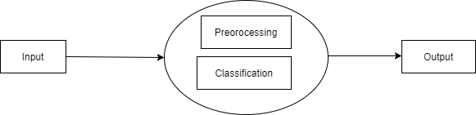

Figure 4.3: Data Flow diagram

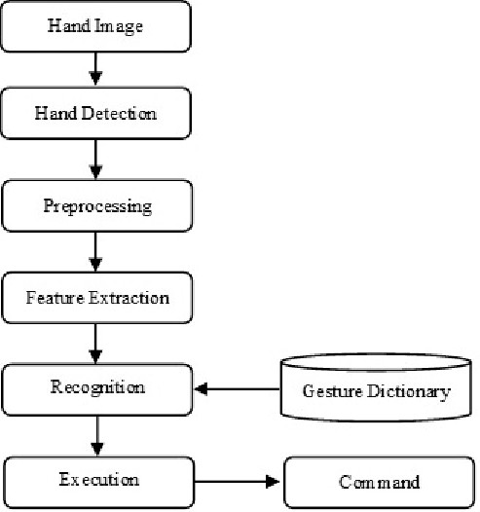

Figure 4.4: Data Flow diagram

## UML DIAGRAMS

Unified Modeling Language is a standard language for writing software blueprints.The UML may be used to visualize,specify,construct and document the artifacts of a soft- ware intensive system.UML is process independent,although optimally it should be used in process that is use case driven, architecture-centric, iterative, and incremental. The Number of UML Diagrams is available.

Use case Diagram.

Component Diagram.

Activity Diagram.

Sequence Diagram.

## Use Case Diagram

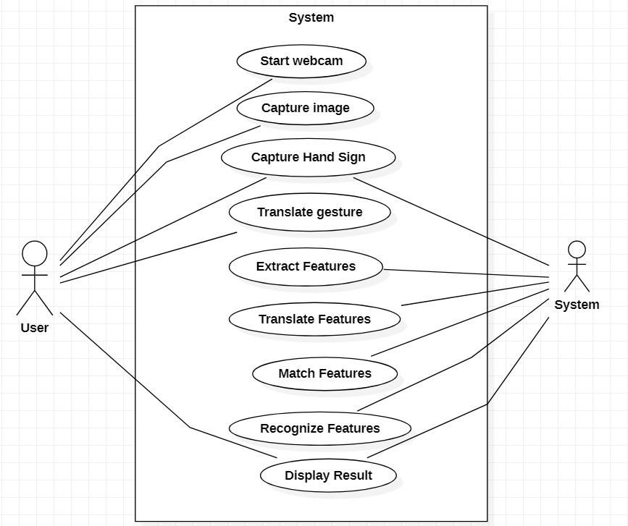

Figure 4.5: Use case Diagram

## Activity Diagram

Figure 4.6: Activity Diagram

## Sequence Diagram

4.7: Sequence Diagram

## Class Diagram

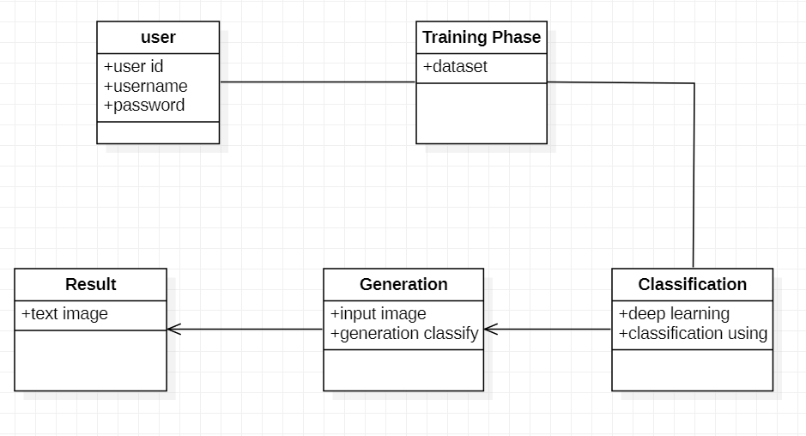

Figure 4.8: Class Diagram

## Entity Relationship Diagrams

Figure 4.9: Entity Relationship Diagrams

# CHAPTER 5

**PROJECT IMPLEMENTATION**

30

## Overview of Project Modules

The module consists of a model file that is trained on a labeled dataset to predict the signs made by the user. We have used many inbuilt Python libraries like keras, TensorFlow, NumPy, scikit-learn to build this model and train it. A dataset consisting of over 2000 images for each gesture was created by using real time data collection. Once the model is trained it can recognize over 27 hand gestures.

## Tools And Technology Used

* + 1. Software Requirement:

Operating System: Windows 10 IDE: Pycharm spyder Programming Language : Python

* + 1. Hardware Requirement: Hardware : intel core Speed : 2.80 GHz

RAM : 8GB

HardDisk : 500GB

Key Board: Standard Windows Keyboard

## Algorithm

CNN : Convolutional Neural Networks specialized for applications in image amp; video recognition. CNN is mainly used in image analysis tasks like Image recognition, Object detection amp; Segmentation. There are Four types of layers in Convolutional Neural Networks:

* + 1. Convolutional Layer: In a typical neural network each input neuron is connected to the next hidden layer. In CNN, only a small region of the input layer neurons connect to the neuron hidden layer.
    2. Pooling Layer: The pooling layer is used to reduce the dimensionality of the feature map. There will be multiple activation amp; pooling layers inside the hidden layer of the CNN.
    3. Flatten: - Flattening is converting the data into a 1-dimensional array for inputting it to the next layer. We flatten the output of the convolutional layers to create a single long feature vector.
    4. Fully-Connected layer:Fully Connected Layers form the last few layers in the network. The input to the fully connected layer is the output from the final Pooling or Convolutional Layer, which is flattened and then fed into the fully connected layer

# CHAPTER 6 SOFTWARE TESTING

## Type of Testing

* + 1. Unit Testing:

It is the testing of individual software units of the application .it is done after the complexion of an individual unit before integration. Unit testing involves the design of test cases that validate that the internal program logic is functioning properly, and that program inputs produce valid outputs. All decision branches and internal code flow should be validated. This is a structural testing, that relies on knowledge of its construction and is invasive. Unit tests perform basic tests at component level and test a specific business process, Application, and/or system configuration. Unit tests ensure that each unique path of a. Business process performs accurately to the documented specifications and contains. Clearly defined inputs and expected results.

* + 1. Regression Testing:

Regression testing is a software testing practice that ensures an application still functions as expected after any code changes, updates, or improvements. Regression testing is responsible for the overall stability and functionality of the existing features.

* + 1. Smoke Testing:

Smoke Testing comes into the picture at the time of receiving build software from the development team. The purpose of smoke testing is to determine whether the build software is testable or not. It is done at the time of ”building software.” This process is also known as ”Day 0”. It is a time-saving process. It reduces testing time because testing is done only when the key features of the application are not working or if the key bugs are not fixed. The focus of Smoke Testing is on the workflow of the core and primary functions of the application.

* + 1. System Testing:

System Testing is a type of software testing that is performed on a complete integrated system to evaluate the compliance of the system with the corresponding requirements. In system testing, integration testing passed components are taken as input. System Testing is a black-box testing. System Testing is performed after the integration testing and before the acceptance testing.

## Test Cases And Test Results

* + 1. GUI Testing:

|  |  |
| --- | --- |
| Test Case | Identification of the letter C |
| Objective | Letter C should be correctly identified |
| Expected Result | Letter C is Correctly identified |
| Test Case | Identification of the letter V |
| Objective | Letter V should be correctly identified |
| Expected Result | Letter V is Correctly identified |

# CHAPTER 7 RESULT

**7.1 Result And Screenshots:**

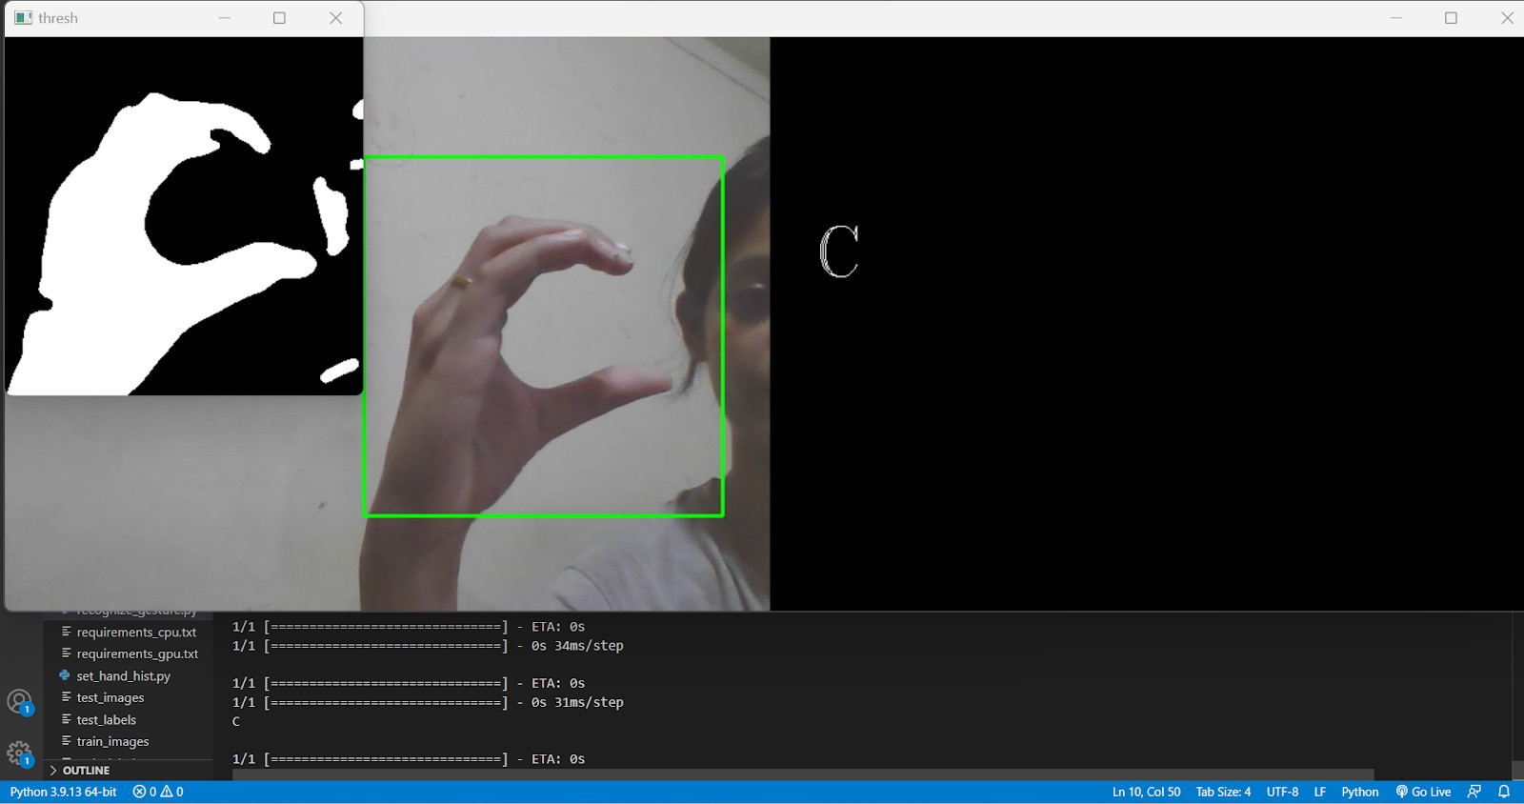

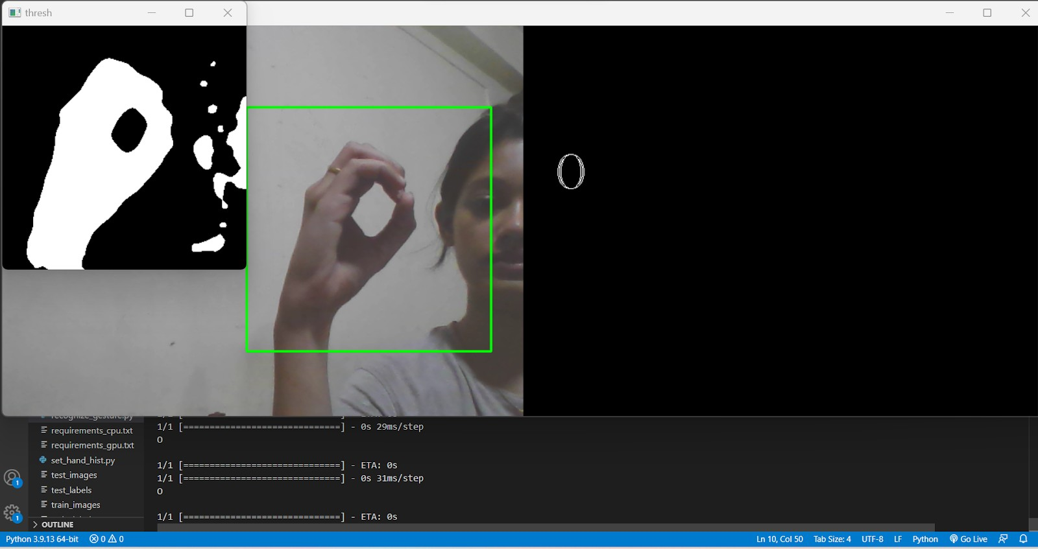

Dr. D. Y. Patil Institute Of Technology 34

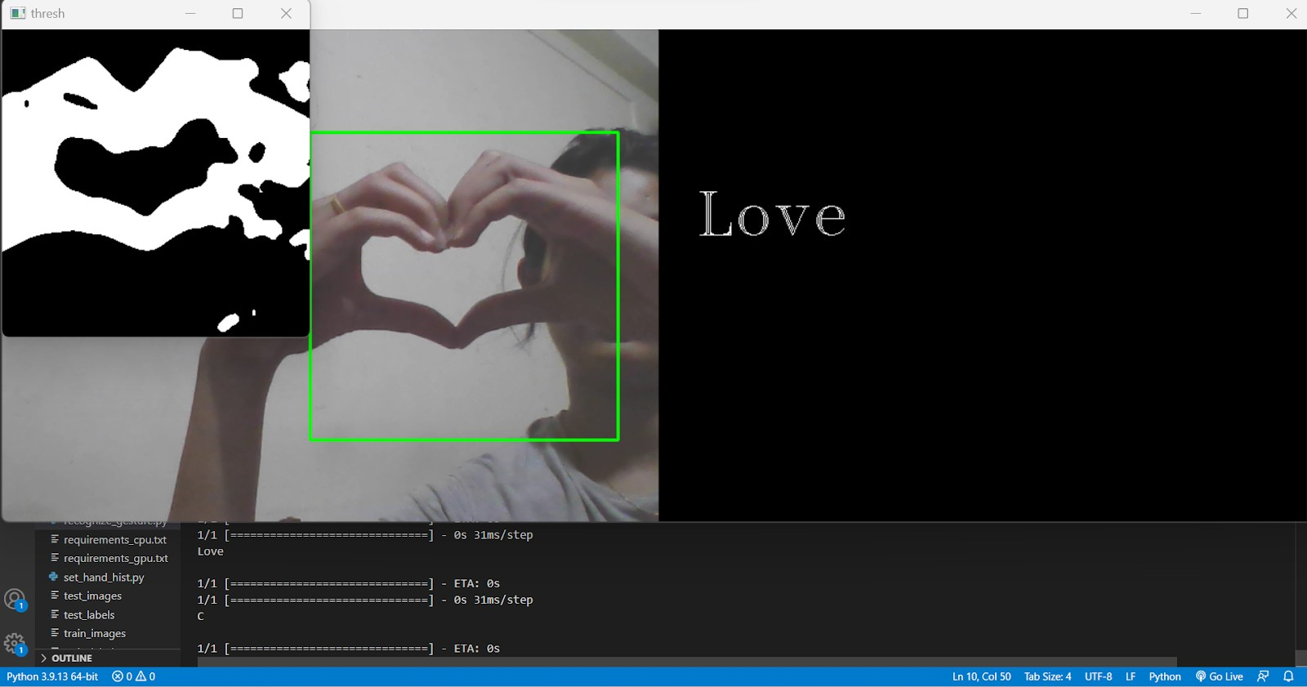

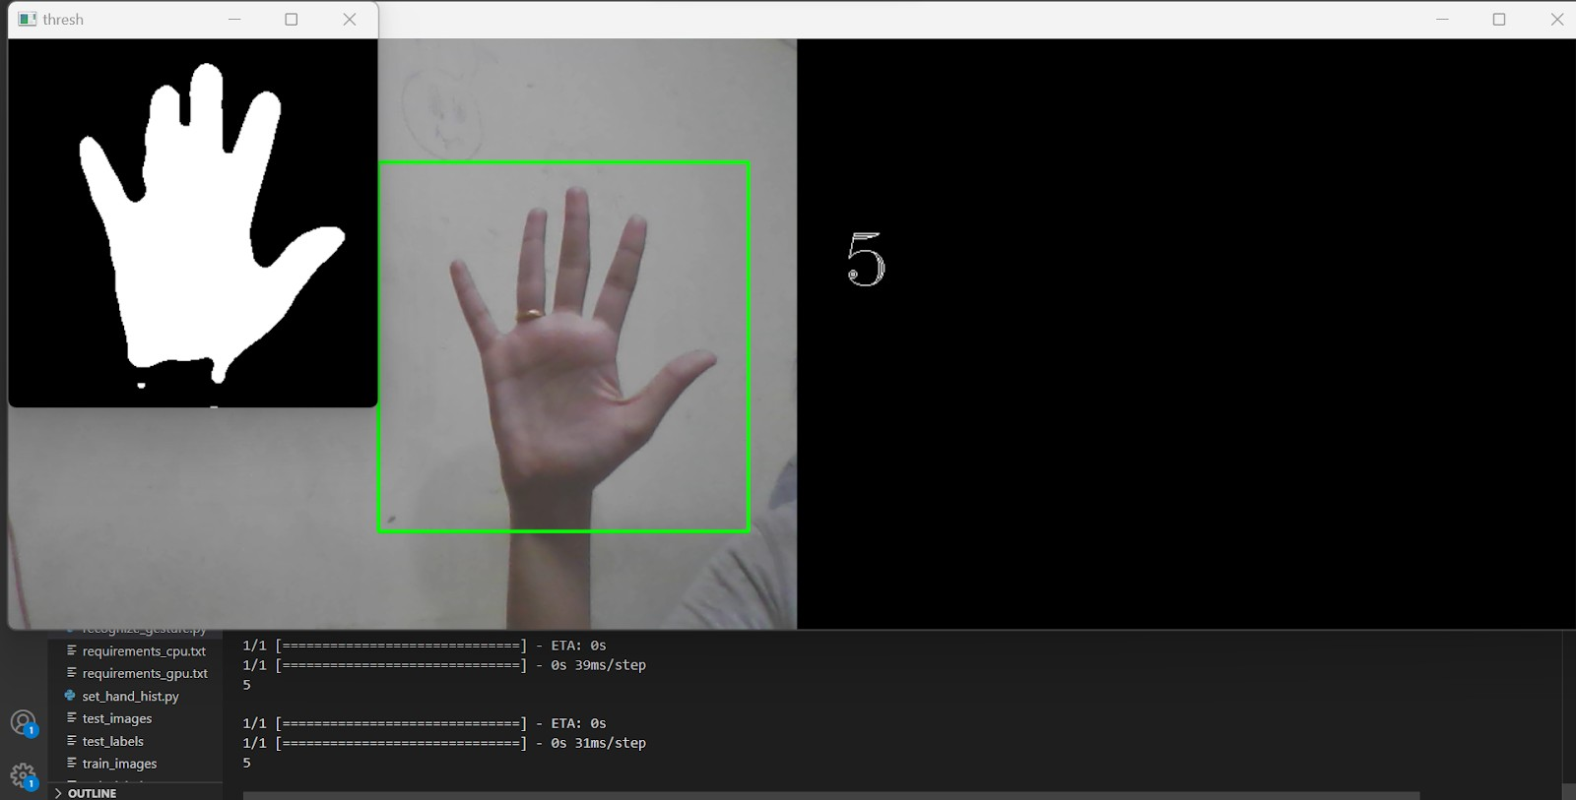

Dr. D. Y. Patil Institute Of Technology 35

# CHAPTER 8 CONCLUSION

## Conclusion

Sign Language is a tool to reduce the communication gap between deaf-mute people and normal people. This system which is proposed above gives the methodology which aims to do the same as the two-way communication is possible. This method proposed here facilitates the conversion on the sign into speech. This overcomes the requirement of a translator since real time conversion is used. The system acts as a voice of the person who is deaf-mute. This project is a step towards helping specially challenged people. This can be further enhanced by making it more user friendly, efficient, portable, compatible for more signs and as well as dynamic signs. This can be further improved so as to make it compatible for the mobile phones using the built-in camera of the phone. We can increase the distance at which it can be used by using a longer trans-receiver module or over Wi-Fi.

## Future Work

In future work, a proposed system can be developed and implemented using Raspberry Pi. The Image Processing part should be improved so that In future work, proposed systems can be developed and implemented using Raspberry Pi. The Image Processing part should be improved so that System would be able to communicate in both directions i.e.it should be capable of converting normal language to sign language and vice versa. We will try to recognize signs which include motion. Moreover we will focus on converting the sequence of gestures into text i.e. word and sentences and then converting it into speech which can be heard.

Dr. D. Y. Patil Institute Of Technology 37

# ANNEXURE A APPENDIX A

**What is P?** • P is a set of all decision problems which can be solved in polynomial time by a deterministic solution.

* Since it can be solved in polynomial time, it can be verified in polynomial time.
* Therefore, P is a subset of NP.

## P

A novel abstractive multi-document summarization system based on chunk-graph (CG) and recurrent neural network language model (RNNLM). A CG which is based on word-graph is constructed to organize all information in a sentence cluster, CG can reduce the size of graph and keep more semantic information than word-graph. System outperforms all baseline systems and reach the state-of-art systems, and the system with CG can generate better summaries than that with

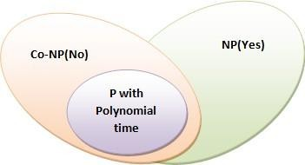

ordinary word-graph.

## What is NP?

* ”NP” means we can solve it in polynomial time if we can break the normal rules of step-by-step computing”.

## What is NP Hard?

A problem is NP-hard if an algorithm for solving it can be translated into one for solving any NP-problem (nondeterministic polynomial time) problem. NP-hard

therefore means ”at least as hard as any NP-problem,” although it might, in fact, be harder.

## Np-Hard:

A CG which is based on word-graph is constructed to organize all information in a sentence cluster, CG can reduce the size of graph and keep more semantic information than word-graph. We use beam search and character-level RNNLM to generate readable and informative summaries from the CG for each sentence cluster, RNNLM is a better model to evaluate sentence linguistic quality than n-gram language model. The system with CG can generate better summaries than that with ordinary word- graphs.

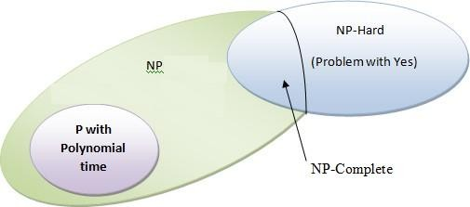

## What is NP-Complete?

* Since this amazing ”N” computer can also do anything a normal computer can, we know that ”P” problems are also in ”NP”.
* So, the easy problems are in ”P” (and ”NP”), but the really hard ones are

*only* in ”NP”, and they are called ”NP-complete”.

* It is like saying there are things that People can do (”P”), there are things that Super People can do (”SP”), and there are things *only* Super People can do (”SP- complete”).

## NP-Complete:

As our system is in developing state so we can’t say that our system is currently in NP complete state

## Ideas of pattern-growth in uncertain environment:

The ideas of pattern-growth in an uncertain environment, two alternative algorithms are designed to discover all the STP candidates with support values for each user. That provides a trade-off between accuracy and efficiency. The user-aware rare pattern concerned here is a new concept and a formal criterion must be well defined, so that it can effectively characterize most of personalized and abnormal behavior of Internet users.

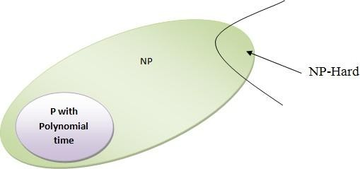

# ANNEXURE B

**PAPER PUBLISHED**

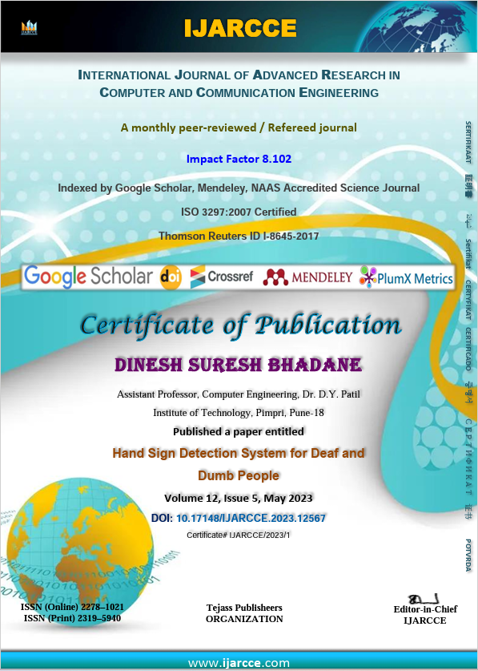

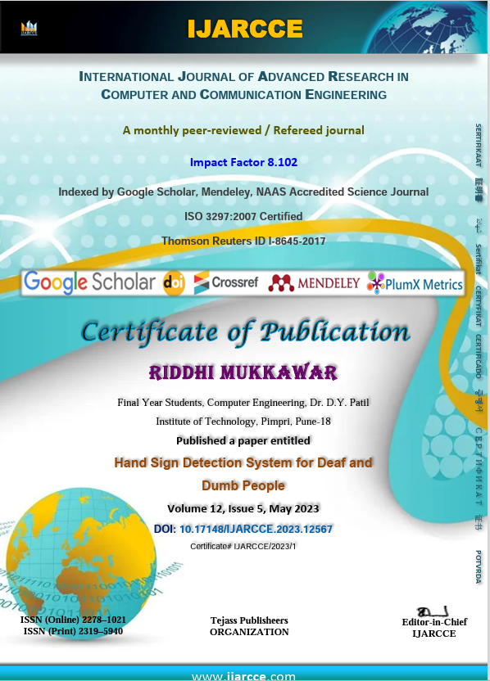

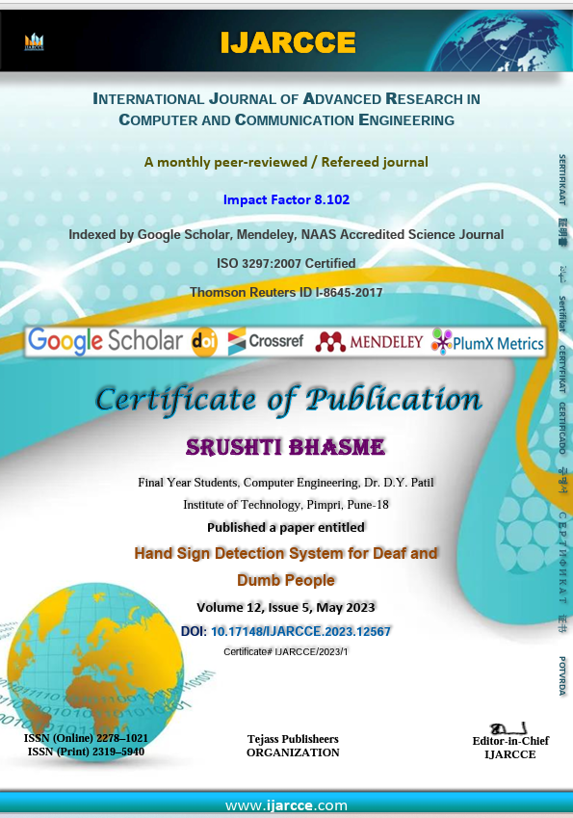

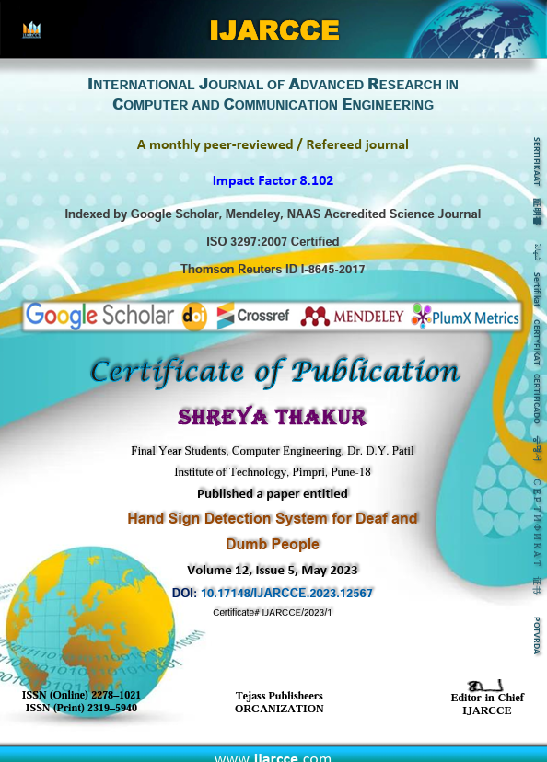

# ANNEXURE C

# PLAGIARISM REPORT

Dr. D. Y. Patil Institute Of Technology 48

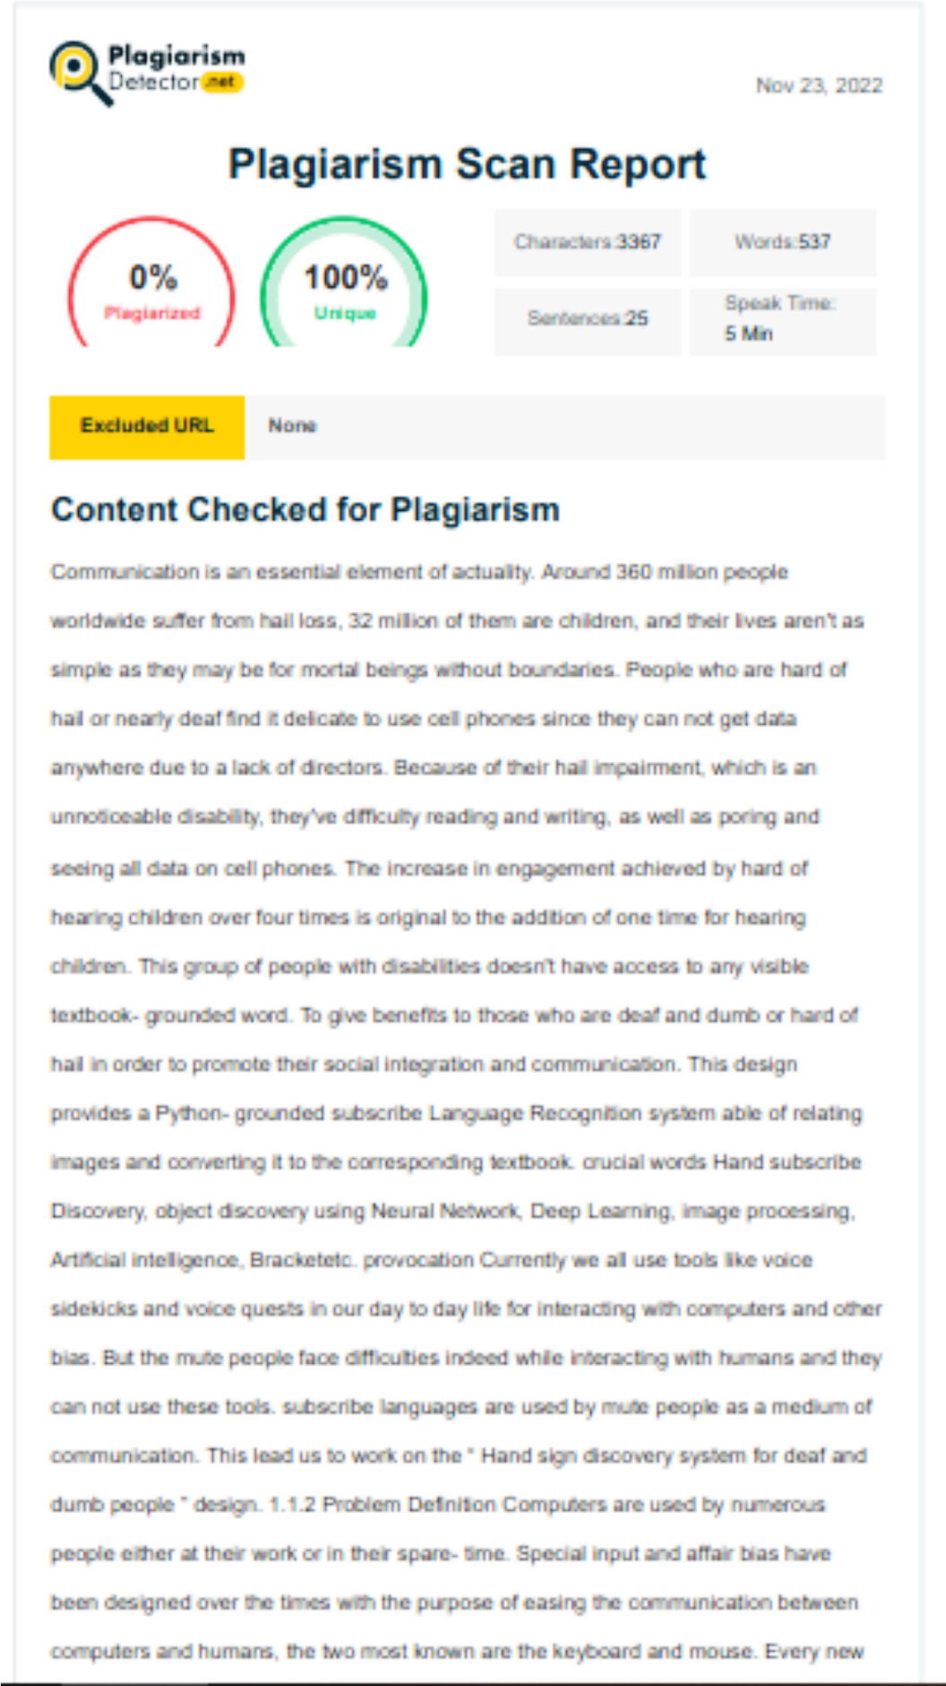

Dr. D. Y. Patil Institute Of Technology 49

**REFERENCES**

Dr. D. Y. Patil Institute Of Technology 50

* + 1. Abdul Mannan, Abdul Abbasi, Abdul Rehman Javed, Anam Ahsan, Thippa Reddy Gadekallu , and Qin Xin "Hypertuned Deep Convolutional Neural Network for Sign Language Recognition" April 2022 Hindawi Computational Intelligence and Neuroscience Volume 2022.
    2. Carl Jose M. Guingab, Ron Andrew Relayo, Mark Joseph C. Sheng, John Ray D. Tamayo "Using Deep Learning in Sign Language Translation to Text" March 7, 2022 International Conference on Industrial Engineering and Operations Management Istanbul, Turkey
    3. Joyeeta Singha , Karen Das “Indian Sign Language Recognition Using Eigen Value Weighted Euclidean Distance Based Classification Technique”

.Assam Don Bosco University Guwahati, India

* + 1. S. Aly and W. Aly, “Deeparslr: A novel signer independent deep learning framework for isolated arabic sign language gestures recognition,” IEEE Access, vol. 8, pp. 83 199–83 212, 2020.
    2. R. Rastgoo, K. Kiani, and S. Escalera, “Hand sign language recognition using multi-view hand skeleton,” Expert Systems with Applications, vol. 150, p. 113336, 2020.
    3. R. Fatmi, S. Rashad, and R. Integlia, “Comparing ann, svm, and hmm based machine learning methods for american sign language recognition using wearable motion sensors,” in 2019 IEEE 9th Annual Computing and Communication Workshop and Conference (CCWC). IEEE, 2019, pp. 0290–0297.
    4. C. K. Lee, K. K. Ng, C.-H. Chen, H. C. Lau, S. Chung, and T. Tsoi, “American sign language recognition and training method with recurrent neural network,” Expert Systems with Applications, vol. 167, p. 114403, 2021.
    5. M. Al-Hammadi, G. Muhammad, W. Abdul, M. Alsulaiman, M. A. Bencherif, T. S. Alrayes, H. Mathkour, and M. A. Mekhtiche, “Deep learning-based approach for sign language gesture recognition with efficient hand gesture representation,” IEEE Access, vol. 8, pp. 192 527–192 542, 2020.
    6. G. Yuan, X. Liu, Q. Yan, S. Qiao, Z. Wang, and L. Yuan, “Hand gesture recognition using deep feature fusion network based on wearable sensors,” IEEE Sensors Journal, vol. 21, no. 1, pp. 539–547, 2020.
    7. S. Kim, Y. Ji, and K.-B. Lee, “An effective sign language learning with object detection based roi segmentation,” in 2018 Second IEEE International Conference on Robotic Computing (IRC). IEEE, 2018, pp. 330– 333.

Dr. D. Y. Patil Institute Of Technology 51

52